EROAD named finalist for Hi Tech Company of the Year 2024

We’re thrilled to share that EROAD has been selected as a finalist in the PwC Company of the Year Category of the 2024 NZ Hi-Tech Awards!
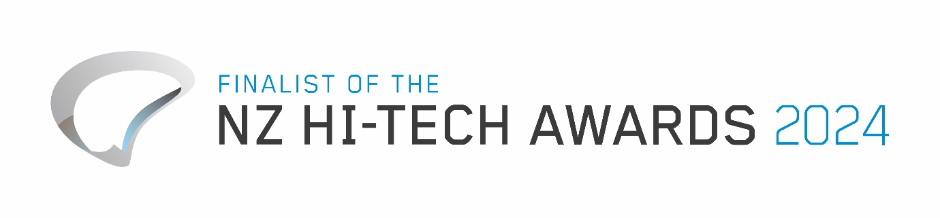

We’re humbled to have been named as finalists in this highly prestigious category, alongside other incredible kiwi tech success stories.

Thank you to our team, customers and partners who have helped us grow EROAD into the global business we are today.

Congratulations to all the other finalists in this year’s Hi Tech Awards.

The winner of the award will be announced at the Hi Tech Awards on 24 May 2024.

